# LAB 1: Understanding the color-coding standard of UTP cable and construction and verification of straight through and Crossover cable.

**Objectives(s):**

* To understand the color coding standard of UTP cable
* To create straight and crossover cable and test/verify its connectivity.

**Apparatus:** Twisted pair Cable, RJ-45 connector, Crimping Tool, Cable Tester

**Background:**

Unshielded Twisted Pair, a UTP cable is a popular type of cable that consists of two wires twisted around each other. A standard UTP cable consists of a 100-ohm copper cable made with 2 – 1800 unshielded twisted pairs shielded by an outer jacket. As UTP cables do not have insulation between each of the paired wires, the cable diameter is reduced but cannot avoid electrical interference. Unshielded Twisted Pair cables are used for a steady network tailor-made for data transfer and telephony.

Working from left to right, the order of the wires shall be set with EIA 568 A or B standard as follows:

**Straight-Through**

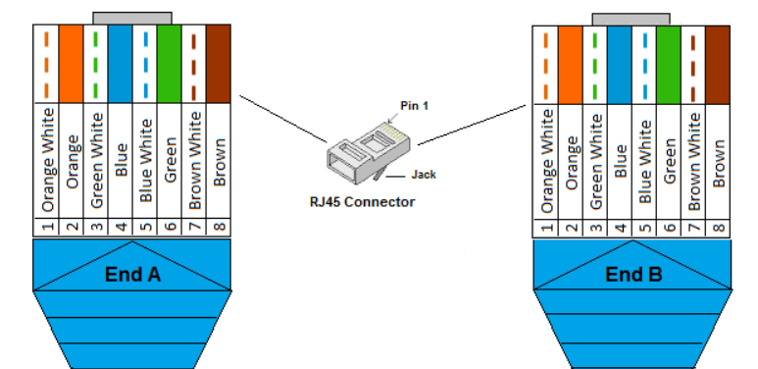

**Crossover**

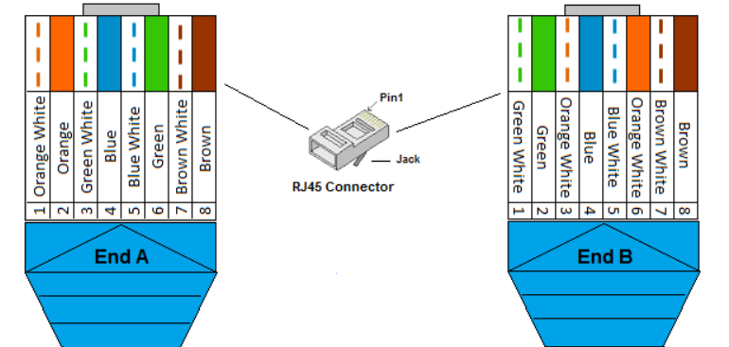

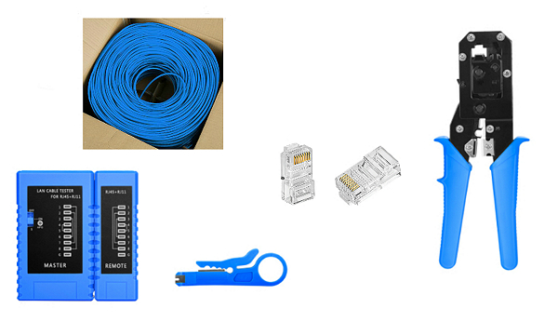

**Procedure:** To do these practical following steps should be done:

There are four pairs of wires in an UTP cable, and an Ethernet connector (8P8C) has eight pin slots. Each pin is identified by a number, starting from left to right, with the clip facing away from you.

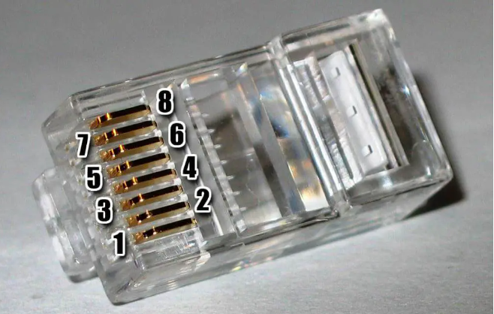

Step 1: Cut into the plastic sheath about 1 inch (2.5 cm) from the end of the cut cable.

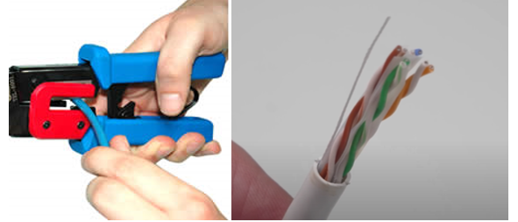

Step 2: Unwind and straighten the wires inside of the cable. Inside of the cable, a bunch of smaller wires twisted together. Separate the twisted wires and straighten them out.

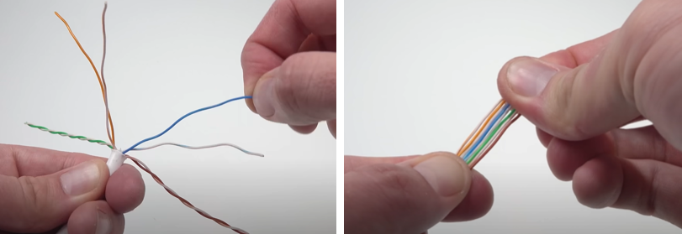

Step 3: Pinch the wires between your fingers and straighten them out in a sequence of color. The proper sequence is as follows from left to right: Orange/White, Orange, Green/White, Blue, Blue/White, Green, Brown/White and Brown.

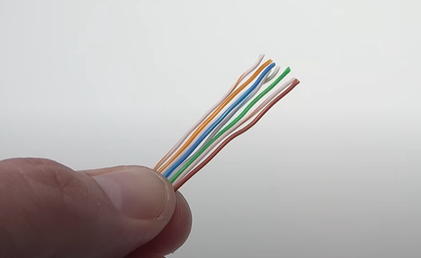

Step 4: Cut the wires into an even line 1⁄2 inch (13 mm) from sheathing, use the cutting section of the crimping tool to cut them into an even line.

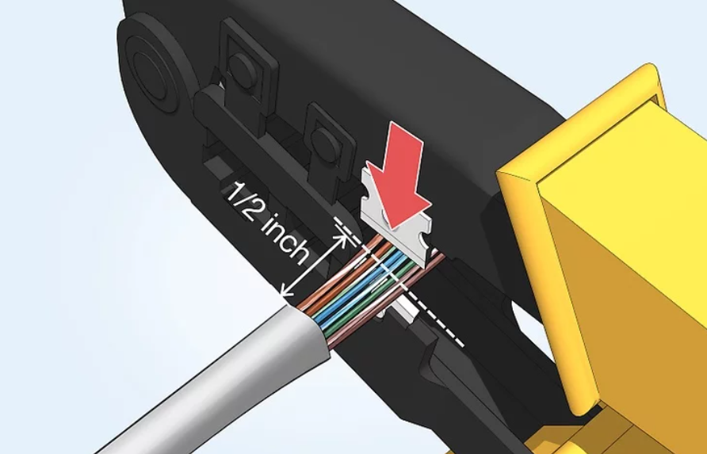

Step 5: Carefully push all 8 unstrapped colored wires into the Rj-45 connector. Hold the RJ-45 connector so the clip is on the underside and the small metal pins are facing up. Insert the cable into the connector so that each of the small wires fits into the small grooves in the connector.

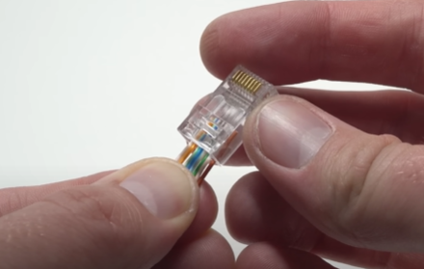

Step 6: Place the connector into the Ethernet Crimper and cinch down on the handles tightly until the crimping section of the tool can’t fit any further.

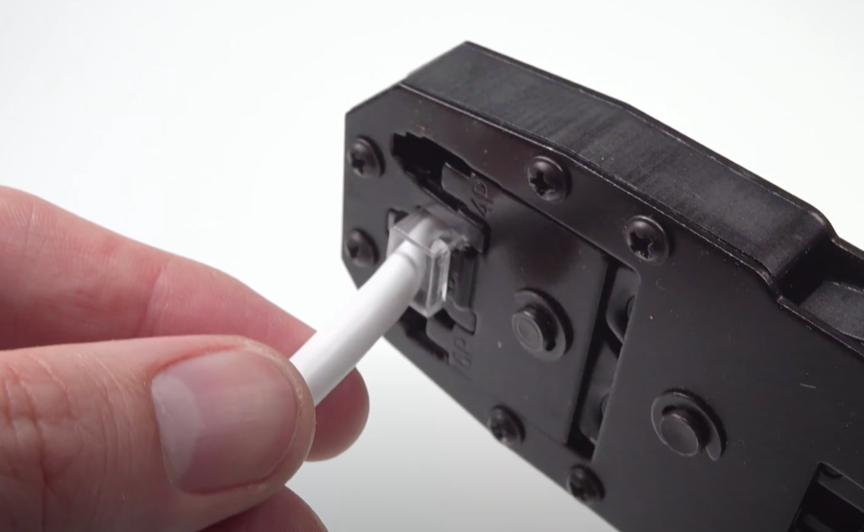

Step 7: Remove the cable from the tool and check that all of the pins are down.

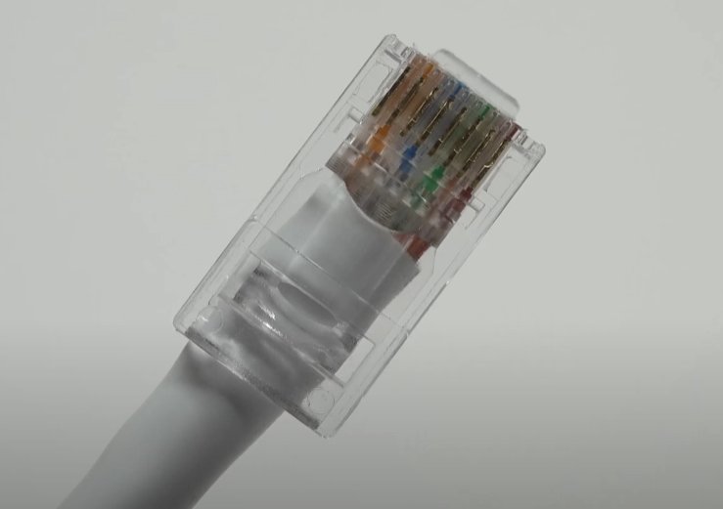

Step 8: Repeat steps 1-7 for the other end of the cable.

Step 9: To make sure you have successfully terminated each end of the cable, use a cable tester to test each pin.

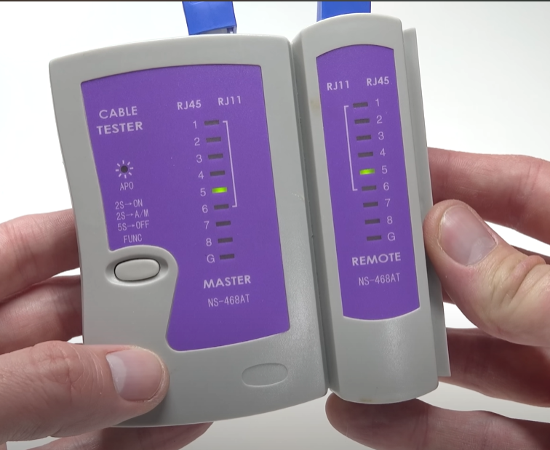

When you are all done, the connectors should look like this:

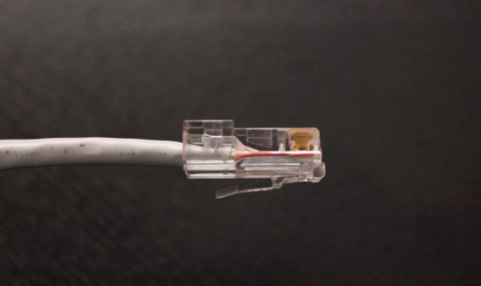

For crossover cables, simply make one end of the cable a T568A and the other end a T568B.

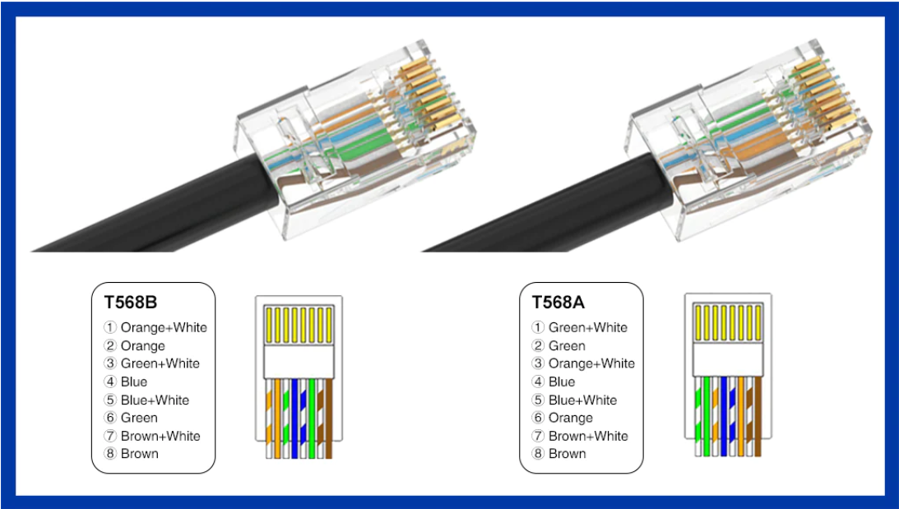

**Conclusion:**

An UTP cable is a common type of network cable used with wired network. UTP cables connect device such as PC’s, router and switches within a LAN. Cross-over cable connect same device whereas straight through cable connect different device.